

Faculty of Applied Sciences  
Bachelor of Science in Computing

**COMP490 Final Year Project  
Project Proposal**Academic Year 2022/23

|  |  |
| --- | --- |
| Shader-Based Image Processing Tools | |
|  |  |
| Project number: | Your project number |
| Student ID: | P-19-0835-1 |
| Student Name: | Versa Xu |
|  |  |
| Supervisor: | Liam Li |
| Assessor: | Your assessor |
|  |  |
| Submission Date: | 8th/Sep/2022 |

Table of Contents

1 Project Description 2

2 Summary of Related Work and Key References 3

3 Project Workplan 4

4 Risk Assessment 4

References 7

# Project Description

Nowadays, technologies of processing digital images have become more and more advanced. Widely used in the traditional field of agriculture, military, industry, medical science and so on, digital image processing plays a significant role in dealing with huge amount of pictures containing fragmented information. Particularly, some advanced techniques such as AI, Autonomous driving are in urgent need of high-speed, real-time and precise GPU algorithms to process various kinds of pictures captured by the carried camera. Computers, mathematics and applications are three main attributes that affect its development and innovation, which finally depends on one indispensable topic: Algorithm.

The project aims to design and generate some graphics processing tools under the functionality of GPU on a interactive online software. The major objectives of this project are listed as follows:

* Study the characteristics of digital image and relevant processes of how to deal with the multidimensional array in Shader Language.
* Design and implement some digital image processing algorithms as shader running on GPUs and ensure their availability and efficiency at a prominent level.
* Design and implement an user-friendly and interactive online application that supports the predefined digital image processing functions, allows users to make some changes on their uploaded graphics, including image flick, image twist, image enhancement, and image blur, etc.
* Provide an approach for users to arrange and manage the uploaded images, in an organized and clear interface to browse those original graphics and results.
* The algorithms and the application are able to protect the personal information of users and their uploaded images.
* (Optional) Researching on matrix algorithms and images security to improve the overall performance.

In this project, the whole product will provide a website containing many convenient and efficient functions in processing digital images. The power of GPUs with 4-8 or more cores can maximize the processing speed and save more running memory compared to using CPU. In this case, it can be possible to fully benefit from the advantages in dealing with many graphics or pictures simultaneously, better solving the issues that the current CPUs or some other algorithms are not able to implement the operation in a rapid way.

Obviously, there exists various kinds of challenges to face in the continuous developing steps. Firstly, it could be quite difficult to use GPU efficiently as we have to develop different shaders running simultaneously and corporate with each other to fulfill one specific graphic. The major shaders we consider will be geometric shader and fragment shader, which are used to process 3D matrix and reflect the graphic onto the screen, respectively. Subsequently, the problem of inconsistency of hardware and software may restrict some special performances. For example, many parts of old-version GPU are unable to deal with huge graphics at the same time, causing risk obstruct or even poor work force. The size of video memory is likely to be the attribute to affect the whole processing flow as well.

# Summary of Related Work and Key References

With the rising requirements of digital images rendering and decorating, more and more people choose to apply some software to make some changes on their individual images online in their daily life. Some products such as Photoshop [1] and uupoop [2], aiming at changing almost all the attributes of a special graphic professionally, have been most popular in the digital image processing field. But actually, Photoshop does not own an easy-to-use interface for the public to make full use of all the functions, while the online application uupoop is not able to deal with those pictures in big size very quickly. Based on these two problems, this project decides to develop a user-friendly and powerful image processing website.

In the meanwhile, some prominent products of GPU also contribute to the whole progress of digital graphics processing. For instance, NVIDIA [3] developed the popular developing model, CUDA [4](Compute Unified Device Architecture), providing a comprehensive settle of solutions in programming on GPU. This company struggled to apply C programming language to manage and maintain the operation of storage unit and stream processor, so that developers would no longer need to use traditional image processing API, which remarkably reduces the difficulty of developing some computing functions on GPU.

We have to mention that the overall programming model of GPU is far more different from the CPU ones. As GPU handles parallel programming, many marvellous algorithms running on those serial CPUs could not be invoked into the structure of GPU. Therefore, the system design of a project with GPUs should be considered in more details. It means that we have to develop something new to process our specific tasks or refer to some algorithms created under the using environment of CPU.

# Project Work Plan

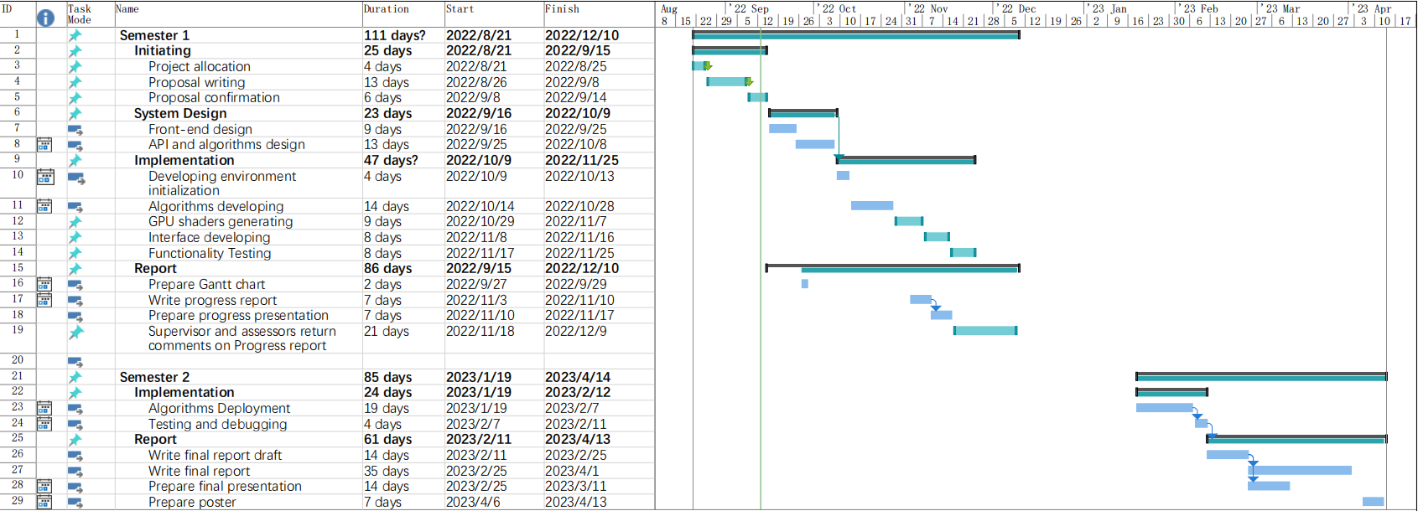

# Risk Assessment

**Risk 1:** **Version management confusion**

Different versions of the same project affect the processes of system design as the overall website runs compatibly with many functions. If each iteration does not update the algorithms or interface components from the previous version, user may not able to correctly figure out the availability and functionality of each function. What’s worse, not updating all functions at the same time in different versions can lead to a chaotic and unmanageable project.

Solution: When the project has many kinds of functions or usage model, we have to ensure that all the things that needs to be updated are listed clearly and updated synchronously. And the project should inform the user what the new version have changed compared to the previous one, in order to avoid the accidents that users’ experience drops because of unwilling to update.

**Risk 2: Users rejects the product due to the unfriendly user interface**

The user interface of the application is not user-friendly, such as poor interface design, which makes users confused and difficult to apply those functions, which may eventually cause users to refuse to use the application.

Solution: In the design phase, follow some widely used design principles, such as The Eight Golden Rules [6]. Also in the product development process, arrange some UI-related tests and find some users with IT background for the first stage of testing and use, try to find out what may be unfriendly to ordinary users and make improvements.

**Risk 3: System do not support the different device**

The digital images processing website is designed to be used in devices with GPU while some people may use it in mobile devices. These devices may not able to run shaders on GPU, causing the failure of running algorithms. In the meanwhile, software and hardware incompatibilities should be considered. In many situations such as power saving mode and non-performance mode, the user may not be able to perceive the benefits of using GPU to process digital images.

Solution: Take widely testing before implementation. Also give the user some hints of their current devices before really applying the project environment.

**Risk 4: User data breach**

The user upload photo and some related information are just shown on the web page, so they should not be leakage for other people know. But the hacker may use illegal ways to get these user data or delete the data.

Solution: Backup images prevent a data breach, and regular checking of the website detects the aberrant download action. Enhance the HTTP security.

**Risk 5: Computer failure or development environment problems**

If the computer fails in the development process, the whole project may be stopped. This will seriously affect the progress of the project.

Solution: Make good use of online code repositories such as Github and make regular backups to ensure that the development progress will not be affected even if the computer fails.

**Table of Priority Risk**

|  |  |
| --- | --- |
| Priority | Risk identifier and Description |
| 1 | **Risk 5: Computer failure or development environment problems** |
| 2 | **Risk 4: User data breach** |
| 3 | **Risk 1: Version management confusion** |
| 4 | **Risk 2: User rejects the product due to the unfriendly user interface** |
| 5 | **Risk 3: System do not support the different device** |

Notes: Priority 1 is the highest risk

Table 2: Table of priority risk

As shown in table 2, there are mainly five related risks. The highest risk is computer failure or development environment problems, which may make the whole project use the wrong programming language or developing framework. It is necessary to apply precise developing tools and environment from the initial process and make sure all the codes are carefully saved after executing. The second biggest risk is user data breach. If the website has mo good security, some individual or important images which include private information will be stolen by hacker. Therefore, users will no longer trust the website and feel worried. What’s more, confusing versions may also provide the user with poor using experience, since without a clear version description or updating information, it is hard to recognize the new functions and related changes in the old ones. It is also possible that users might reject the product because of not well-designed interfaces. This can really impact the impression of the website for the first time. Finally, we consider that the system may not be suitable for all the devices as only some PC or laptop have a GPU.

**Probability Impact Matrix (****Initially)**

|  |  |  |  |  |
| --- | --- | --- | --- | --- |
| Probability | High |  | Risk 5 |  |
| Medium |  | Risk 4, Risk 2 | Risk 1 |
| Low |  | Risk 3 |  |
|  | | Low | Medium | High |
| Impact | | |

Figure 1: Probability impact matrix initially

Figure 1 shows the initial risk probability impact, this project occurs in risk5 which has a high probability, risk 4 and risk 2 have medium probability, and risk 3 has a low probability. As see the impact way, risk2,3,4,5 also has medium impact, risk 1 is high impact.

**Probability Impact Matrix (After Applying Solution)**

|  |  |  |  |  |
| --- | --- | --- | --- | --- |
| Probability | High |  |  |  |
| Medium |  |  |  |
| Low | Risk1, Risk 2, Risk 3 | Risk 4, Risk 5 |  |
|  | | Low | Medium | High |
| Impact | | |

Figure 2: Probability impact matrix after applying solution

Figure 2 shows that the risk probability risk after the applying solution, risk 1, risk 2, risk 3 just have a low probability risk and impact. Risk 4, risk 5 also have a medium impact, so it needs to focus on it to prevent this risk occurs.

References

[1] Photoshop https://www.adobe.com/cn/products/photoshop.html

[2] UUPOOP https://www.uupoop.com

[3] NVIIA [Artificial Intelligence Computing Leadership from NVIDIA](https://www.nvidia.com/en-us/)

[4] CUDA https://en.wikipedia.org/wiki/CUDA